# **Good spot for Levantine cuisine restaurant in Paris**

The city of [Paris](https://en.wikipedia.org/wiki/Paris) is divided into twenty [arrondissements municipaux](https://en.wikipedia.org/wiki/Municipal_arrondissements_of_France), administrative districts, more simply referred to as arrondissements.

We can get the detail of JSON file for those Arrondissements from the following link:  
<https://opendata.paris.fr/explore/dataset/arrondissements/table/>

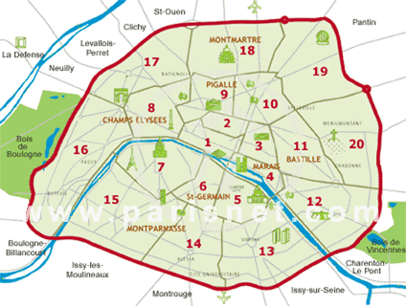

We first download the data, clean it and make sure that the dataset has all 20 Arrondissements of Paris.

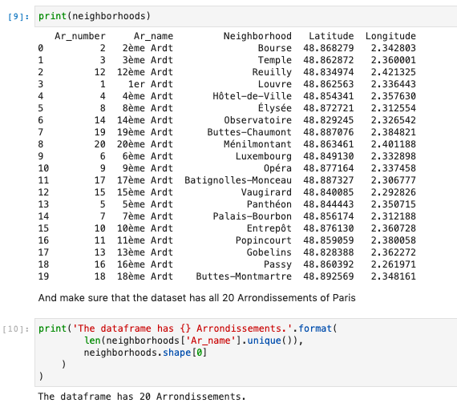

Let’s then show the 20 Arrondissements of Paris on the MAP.

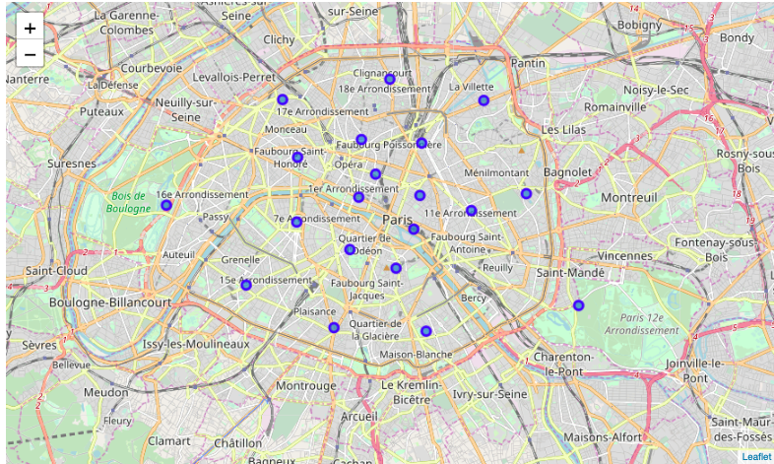

We start to explore all the Neighborhoods of Paris to get up to 100 Venues per Arrondissement.  
Checking the number of venues returned by Foursquare, we got up to 1,405 Venues in Paris’ 20 Arrondissements.

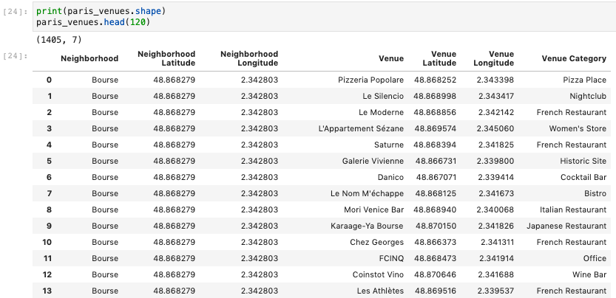

Then we group the returned venues to show the number of restaurants per Arrondissement.

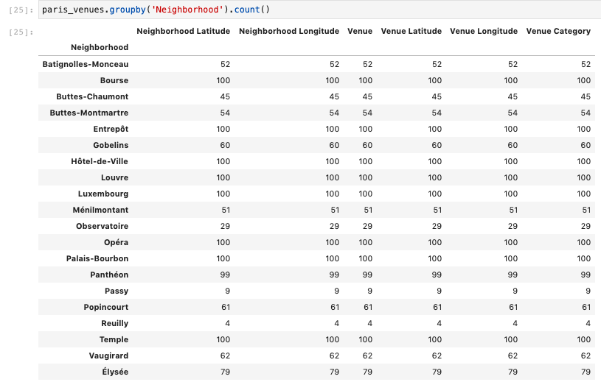

Another view of the Venues categories, shows we have 204 unique venue category.

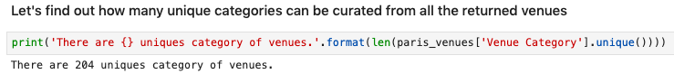

So we need to show all the Levantine cuisine restaurants that might be serving the same type of food as our new restaurant.

From the list of categories, the following restaurants would fall under this category:

* Lebanese Restaurant
* Turkish Restaurant
* Israeli Restaurant
* Kebab Restaurant
* Falafel Restaurant

In order to list Levantine cuisines, we need to filter the following restaurants returned by foursquare:  
Lebanese, Turkish, Israeli, Kebab & Falafel

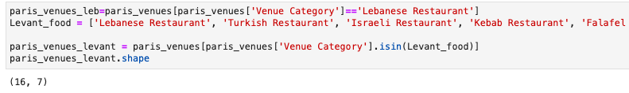

The result are 16 restaurants in Paris with the same type of cuisine. Let’s show them on the map to see how they are scattered and explorer which Arrondissements/Quartiers are the furthest from any of these restaurants.

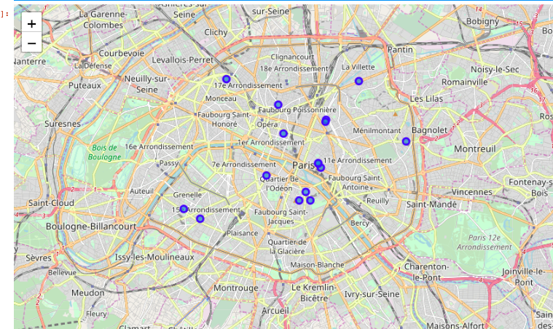

From the map we can see that there are 2 good spots:  
- **Spot 1:** 12eme, 13eme & 14eme Arrondissements  
- **Spot 2:** 7eme, 8eme, 15eme, 16eme & 17Eme Arrondissements

Opening a Levant food restaurant in any of the 2 Spots would have a good advantage as there's no competition for this particular cuisine

